PROJECT REPORT

on

**IoT Smart Jar**

Submitted by

**Harsh Nevse (A1-1032220463)**

**Shriya Samridhi (A1 - 1032221380)**

**Revati Jagdale (A1 - 1032220895)**

Under the Guidance of

Prof. Shweta Kukade



**Department of Electrical and Electronics Engineering**

**Dr. Vishwanath Karad**

**MIT WORLD PEACE UNIVERSITY, PUNE.**

**[2022-2023]**

## 

**Department of Electrical and Electronics Engineering**

Academic Year 2023-2024

**CERTIFICATE**

###### This is to certify that _________________, PRN No. 103222_____ has successfully completed his/her PBL activity entitled **“IoT Smart Jar”** and submitted the same during the academic year 2023-24 as a requirement for completion of continuous assessment component under subject Sensors & Actuators.

Program Director

Batch Coordinator

Date:

Place: Pune

**ACKNOWLEDGEMENT**

**Table of Contents**

|  |  |  |
| --- | --- | --- |
| **Abstract** | |  |
| **1.** | **Introduction** |  |
| 1 | Motivation |  |
|  |  |  |
| **2.** | **Background** |  |
| 2 | Aim and Objectives of Project |  |
| **3.** | **System Development** |  |
| 3.1 | System block diagram |  |
| 3.2 | System Specifications |  |
| 3.3 | Flow chart/ Algorithm implemented |  |
|  |  |  |
| **4.** | **Results** |  |
|  |  |  |
| **6.** | Conclusion |  |
| **7.** | **References** |  |
|  |  |  |

**ABSTRACT**

The IoT Smart Jar is a kitchen inventory and alert system utilizing an ESP32 microcontroller, ultrasonic sensor, integrated with an MQTT panel. This innovative device accurately measures the quantity of stored products and sends alerts to the user's smartphone when the jar is empty. It serves as a practical solution for managing kitchen, medical, or restaurant inventory efficiently. Through real-time monitoring and notification capabilities, users can conveniently track their stock levels and ensure timely replenishment, thereby minimizing waste and enhancing their inventory management.

# CHAPTER 1

# INTRODUCTION

1. **Introduction**

In the ever-evolving landscape of food options and dietary needs within modern households, efficient inventory management is essential. The IoT Smart Jar addresses this necessity by providing users with real-time inventory status updates through timely notifications, enabling better management of kitchen, medical labs, or restaurant supplies. In our daily hectic routines, where grocery shopping might be sidelined, and unplanned and unhealthy binge shopping may happen. Hence by keeping users informed about their current inventory status, this device facilitates proactive planning, reducing the likelihood of unnecessary shopping trips and promoting healthier choices.

Moreover, the benefits of the Smart Jar extend beyond typical household scenarios.  
For blind people or people with visual impairments who live alone, managing kitchen supplies can be challenging. By offering real-time inventory updates and notifications, this device serves as a valuable tool for enhancing accessibility and independence in daily living. Thus, the project not only addresses the needs of busy households but also contributes to inclusivity by providing assistance to individuals with visual impairments, thereby fostering a more inclusive and supportive environment.  
  
A further application may extend to restaurant businesses who need to keep track of their inventory as a business practice. There is scope for more complex application wherein we can build a database for large scale kitchens to keep track of and create a timeline for the amount of product that gets used during a period of time. Restaurant businesses can make wise decisions to do their operations, improve resource allocation, and enhance profitability.

**CHAPTER 2**

1. **AIM AND OBJECTIVES OF PROJECT**

The aim of this project is to develop a smart jar system that enhances inventory management by providing accurate, real-time monitoring and timely alerts.   
The objectives are to design a sturdy hardware system using the ESP32 microcontroller and ultrasonic sensor.   
Then, we aim to implement effective data communication protocols through Arduino IDE and integrate them with MQTT panel.   
And then, we'll focus on improving the user interface to ensure smooth interaction and timely notification delivery.  
Through these objectives, the project aims to empower users with enhanced inventory control capabilities, thereby improving efficiency and reducing wastage.

**CHAPTER-3**

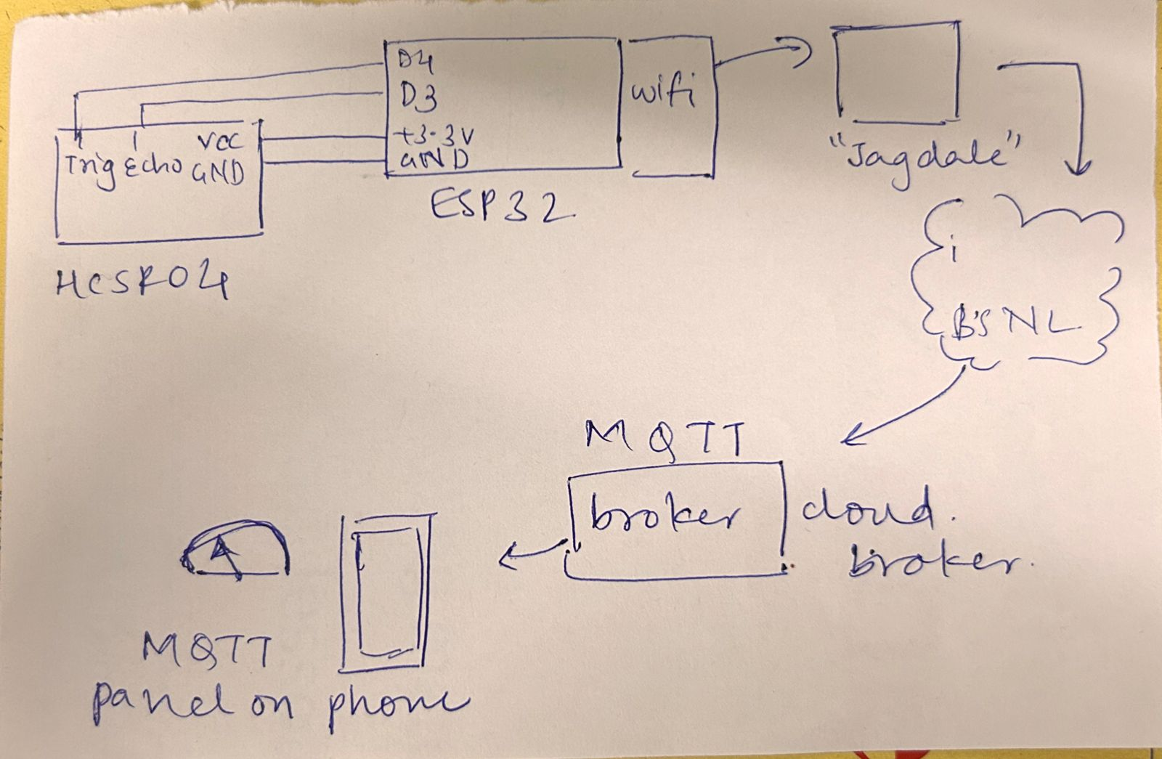**3.1 SYSTEM BLOCK DIAGRAM**

**3.2 SYSTEM SPECIFICATIONS**1. ESP32 Microcontroller: a microcontroller developed by Espressif Systems, featuring a dual-core processor, built-in Wi-Fi and Bluetooth connectivity, and a rich set of peripheral interfaces.Specifications: Processor: Dual-core Xtensa LX6 CPU, clocked at up to 240MHz

Wi-Fi: 802.11 b/g/n (2.4GHz), integrated TCP/IP stack

Memory: Up to 520KB SRAM, 4MB Flash memory

Interfaces: SPI, I2C, UART, ADC, DAC, PWM, etc.  
NodeMCU is an open-source IoT (Internet of Things) platform based on the ESP8266 Wi-Fi module. It can be used to control various electronic devices and make them communicate with each other over a network.

2. HC-SR04 Ultrasonic Sensor: ultrasonic distance sensor capable of accurately measuring distances using ultrasonic waves.

Specifications: Operating Voltage: 5V DC

Operating Current: <15mA

Operating Range: 2cm to 400cm

Resolution: 0.3cm

Trigger Input Pulse: 10μs minimum

Echo Output Pulse: Output a pulse whose width corresponds to the time taken for the ultrasonic wave to return.

3. IoT MQTT Platform: facilitates communication between IoT devices and applications using the MQTT (Message Queuing Telemetry Transport) protocol.

Specifications: Protocol: MQTT (Message Queuing Telemetry Transport),

Reliability and Security.

Lightweight: for low-bandwidth, high-latency, or unreliable networks.   
Integration: Integrates with various IoT devices and applications, enabling seamless data exchange and control.

Scalability: Scalable architecture capable of handling a large number of devices and messages.

Cloud-based: Some platforms offer cloud-based services for easy deployment and management of IoT solutions.

**3.3 SYSTEM ALGORITHM**

The code initializes WiFi and MQTT client connections, sets up pin configurations for the HC-SR04 sensor, and continuously measures distance. It calculates grams based on distance, publishes the data to an MQTT topic, and maintains connections to WiFi and MQTT brokers. If connections are lost, it retries every 2 seconds

**CHAPTER 4**

**4.1 Result**

As we switch on the device, it keeps taking the readings and the app shows the following results.

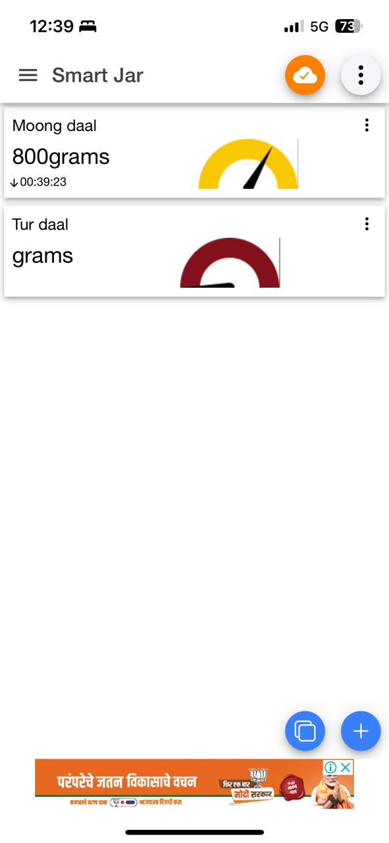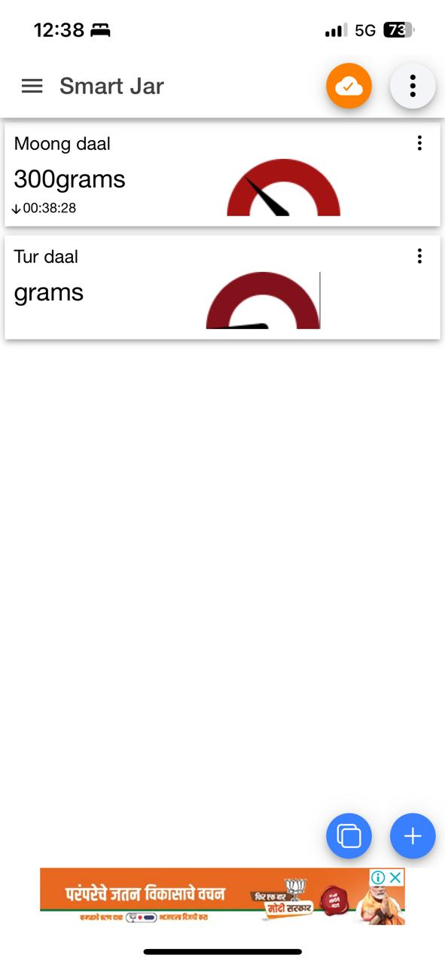

**CHAPTER 5**

**5.1 Conclusion**

Thus, we have successfully implemented the IoT Smart Jar using ESP32 as the microcontroller and HC-SR04 cell as sensors and achieved it’s objectives, thus showcasing our practical knowledge and complete understanding of the subject.